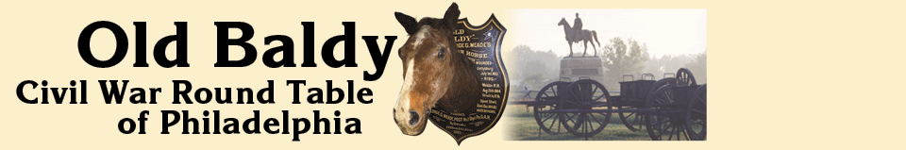

Membership Application

Name: _______________________________________________________

Address: _______________________________________________________

_______________________________________________________

Phone: _______________________________________________________

Email Address: _______________________________________________________

Civil War Interests: _______________________________________________________

_______________________________________________________

_______________________________________________________

Other Interests: _______________________________________________________

Make check out to: Old Baldy CWRT

Send to: Arlene Schnaare
230 Hutchinson Ave
Haddonfield, NJ 08033

Students: $12.50 Individuals: $25.00 Families: $35.00

Please add $10 to receive a hard copy of the newsletter in the mail.

